### Practical No: 01(A)

**Practical Title:** Write a python program to store marks for N students.

**Aim:** - Write a Python program to store marks scored in subject “Fundamental of Data Structure” by N students in the class. Write functions to compute following:

1. The average score of class
2. Highest score and lowest score of class
3. Count of students who were absent for the test
4. Display mark with highest frequency

Prerequisite:

* + Python Programming

Objectives:

To understand the use functions for N students record.

**Input:** N number of students.

**Outcome:** Resulting average, highest and lowest marks operation.

Theory:

**ARRAYS**

Arrays a kind of data structure that can store a fixed-size sequential collection of elements of the same type. An array is used to store a collection of data, but it is often more useful to think of an array as a collection of variables of the same type.

Instead of declaring individual variables, such as number0, number1, ..., and number99, you declare one array variable such as numbers and use numbers[0], numbers[1], and ..., numbers[99] to represent individual variables. A specific element in an array is accessed by an index.

All arrays consist of contiguous memory locations. The lowest address corresponds to the first element and the highest address to the last element.

**Declaring** Arrays

To declare an array in C, a programmer specifies the type of the elements and the number of elements required by an array as follows −

type array_Name [ array Size ];

This is called a *single-dimensional* array. The **arraySize** must be an integer constant greater than zero and **type** can be any valid C data type. For example, to declare a 10-element array called **balance** of type double, use this statement −

double balance[10];

Here *balance* is a variable array which is sufficient to hold up to 10 double numbers.

**Initializing Arrays**

You can initialize an array in C either one by one or using a single statement as follows −

double balance[5] = {1000.0, 2.0, 3.4, 7.0, 50.0};

##### Accessing Array Elements

An element is accessed by indexing the array name. This is done by placing the index of the element within square brackets after the name of the array. For example −

double salary = balance[9];

Functions Used :

**Write algorithm/pseudo code for each function.**

1. The average score of class
2. Highest score and lowest score of class
3. Count of students who were absent for the test
4. Display mark with highest frequency

**Algorithm:**

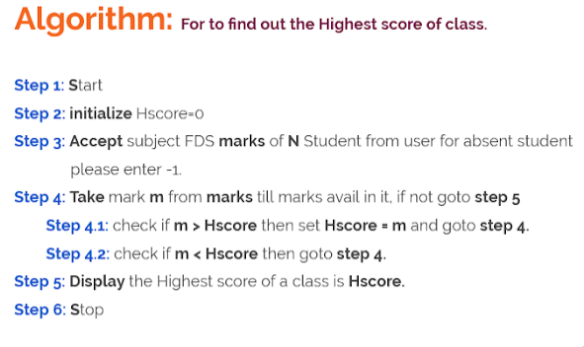

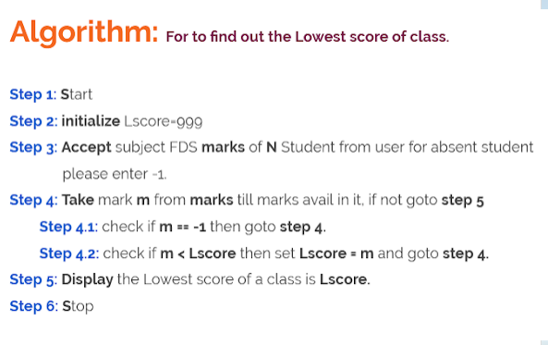

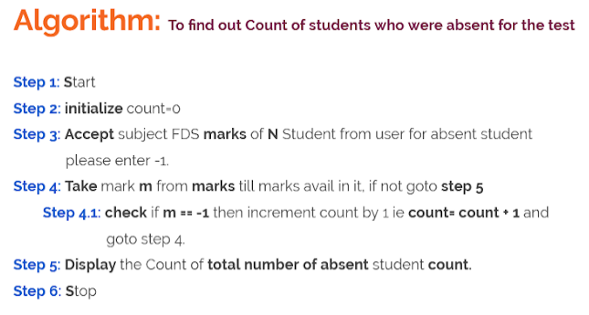

Conclusion:

By this way, we can store the marks of N students sucessfully.

Questions:

1. Basics of python Programming.
2. What are functions?
3. What are the features of python Programming?
4. What are array?